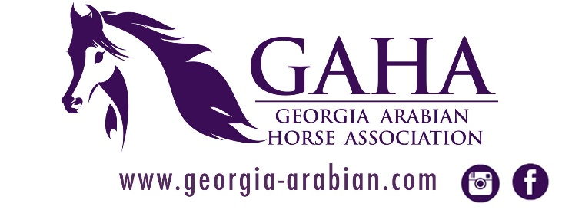

2020 Georgia Arabian Horse Association Introduction to Ranch Riding & Trail Classes with Practice and Q&A
Registration Form
www.georgia-arabian.com

Please join us for a fun day of learning with your fellow equestrians Barbara Adler and Corky Fairchild for an introduction to showing Trail and Ranch Riding. Event is limited to 15 horses for event.
REGISTRATION deadline for Riders is March 8th, 2020!
CURRENT NEGATIVE COGGINS REQUIRED & SIGNED GAHA WAIVERS (see pages 2-3)
Copies of waivers will be available at check-in as well.
HELMETS MUST BE WORN. ALL REGISTRANTS MUST CHECK IN UPON ARRIVAL.

When: Saturday, March 14th, 2020
Where: Deep Creek Arabians 206 Glover Road Zebulon, GA 30295
Time: Check-In~ 8:30AM to 9:30AM, Trail (English and Western)~ 10:00AM - 12:00PM,
Lunch Break~ 12:00 - 1:00PM, Ranch Riding~ 1:00PM - 4:00PM

Name(s): ________________________________________________________________
Address: ________________________________________________________________
Telephone: __________________________ Email: ______________________________
Participants Type:
_______ GAHA Member Auditor: $15.00 - all day auditing. Chili and hot dog lunch included.
_______ Non-GAHA Member Auditor: $20.00 - all day auditing. Chili and hot dog lunch included.
_______ GAHA Member Rider: $30.00 includes all day auditing. Chili and hot dog lunch included.
_______ Non-GAHA Member Rider: $35.00 includes all day auditing. Chili and hot dog lunch included.
​Payment Options – Please Circle One:
CHECK
Make check payable to the Georgia Arabian Horse Association.
Please note "INTRO TO RANCH RIDING & TRAIL," Participant Name(s) & Type on check.
and mail to: GAHA, Susan White, 206 Glover Road, Zebulon, GA 30295
PAYPAL
Please use the "FRIENDS & FAMILY" Option.
If you choose to use a Credit Card please add an additional $5.00 to your amount for the Credit Card processing fee.
Please note "INTRO TO RANCH RIDING & TRAIL," Participant Name(s) & Type on NOTES section of payment.​​
https://www.paypal.me/GeorgiaArabian

To register, please email this form to info@georgia-arabian.com. Payment and form must both be received by March 8th, 2020 to reserve slot.

Event Release and Indemnification Agreement
Georgia Arabian Horse Association
In consideration for the Georgia Arabian Horse Association allowing me to participate in this Event, I agree as follows:
- I agree that I choose to participate voluntarily in this Event as a rider, driver, handler, lessee, owner, agent, coach, trainer, volunteer, junior exhibitor or as a parent or guardian of a junior exhibitor.
- I recognize and understand that participation in equine activities involves certain risks including, but not limit to the following: The propensity of an equine to behave in ways that may result in injury, death or loss to persons on or around the equine. Sounds, sudden movement, unfamiliar objects, the activities of persons and other animals may cause unpredictable behavior in equines. Hazards include surface or subsurface conditions in traveling surfaces, a collision with another animal, people or objects. Weather related hazards may include rain, lightening, thunder, wind, excessive heat or cold, and may affect equine behavior.
- GAHA makes no representation or warranty regarding the safety or condition of the premises, equine equipment or equines on the premises.
- With full knowledge of the above mentioned and any other inherent risks which may be associated with equine activities, I hereby consent to my or my child’s participation in the Event. In doing so, I, the natural and/or lawful parent and/or legal guardian of the minor named below, do so on behalf of and in place of the minor named below and for myself as well as the agents, representatives, assigns, heirs, executors, beneficiaries and assigns of the minor named below and of me, release and forever discharge the Georgia Arabian Horse Association, their officers, officials, directors, employees, agents, personnel, volunteers, affiliated organizations and insurers from any and all claims for damage, loss or injury to myself and/or the minor named below, other persons, horses or property belonging to me or the minor named below to the fullest extent permitted by law that arises out of or relates in any way to the Event and my or my child’s participation in the Event including, but not limited to damages, loss or injury resulting from any acts, failure to act, negligence or neglect of other participants, released parties, their contractors or guests, as well as for theft, vandalism, fire, other casualty damage, or damage arising out of any defect in the premises.
- I agree to indemnify and hold harmless the Georgia Arabian Horse Association, their officers, officials, directors, employees, agents, personnel, volunteers, affiliated organizations and insurers from and against any and all claims, demands, penalties, actions, losses, costs, damages, injuries, liabilities and obligations (including my attorneys’ fees) of whatsoever kind and nature, which may be asserted against or incurred by any of them as a result of my participation in the Event or any act, failure to act, or neglect by (a) me, my agents, employees, riders, handlers, trainers, coaches, drivers, contractors or guests, or (b) any animal owned or exhibited by me or in my custody or control.
- This Agreement is governed by the laws of the State of Georgia. This Agreement constitutes the entire agreement and understanding between the parties with respect to this Event, and supersedes and cancels any previous agreements or understandings, whether oral, written or implied. Should any provision of this Agreement be invalid or unenforceable, that provision shall not invalidate any of the remaining provisions of this Agreement. The parties shall use their reasonable efforts to replace any invalid and/or unenforceable provision with a provision which has the closest meaning and purpose to the invalid or unenforceable provision.

Under Georgia Law, an equine activity sponsor or equine professional is not liable for an injury to or the death of a participant in equine activities resulting from the inherent risks of equine activities, pursuant to Chapter 12 of Title 4 of the Official Code of Georgia Annotated. (O.C.G.A., 4-12-4, West 1981).

I have read and understand the terms of this waiver and release, and voluntarily accept its terms.

Printed Name of Participant: | If Participant is a Minor, Printed Name of Parent or Guardian:
Signature of Participant: | Signature of Parent or Guardian
Date: | Date:

