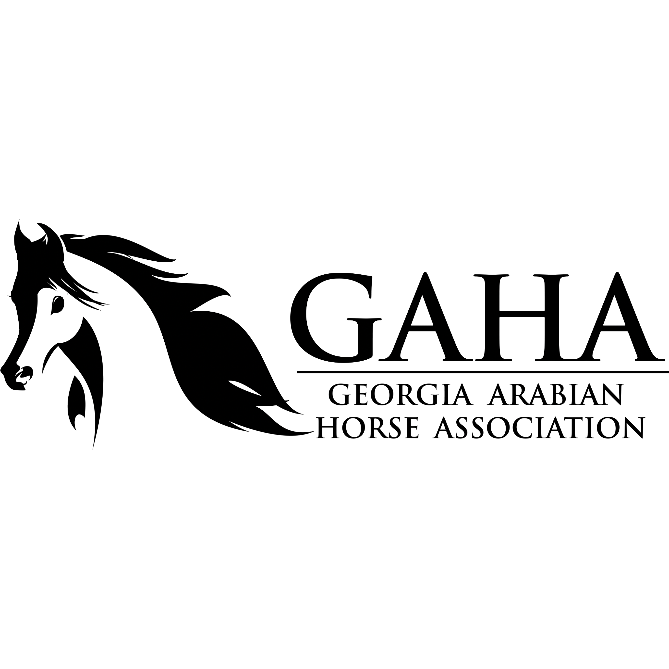

Georgia Arabian Horse Association Member Feature Questionnaire

We want to hear from our members so we can feature and brag on our wonderful members & their lovely Arabian, Half Arabian or Anglo Arabian horse(s)! Keep an eye on our social media & newsletters for our Member Features. Thank you for your time and being a part of GAHA!

Not sure if you are a current GAHA member or need to renew your membership? Please contact our Membership Chairperson at membership@georgia-arabian.com or visit https://www.georgia-arabian.com/membership

Have a fun story or adventure to share? Won an award? Bought a new horse? Have a cute or fun video or photo to share? Be sure to share your adventures & stories on our GAHA Discussion group at: [www.georgia-arabian.com/marketplace](http://www.georgia-arabian.com/marketplace). We want to share the journey of our members with the Arabian/Half Arabian horse!

info@georgia-arabian.com

[www.georgia-arabian.com](http://www.georgia-arabian.com/)

[www.facebook.com/GeorgiaArabianHorseAssociation/](http://www.facebook.com/GeorgiaArabianHorseAssociation/)

[www.instagram.com/georgiaarabianhorse/](http://www.instagram.com/georgiaarabianhorse/)

Name:

Date Questionnaire Submitted:

Email:

What is your AHA/GAHA Member #? Or let us know if you are a GAHA-Only Member. How long have you been a GAHA member?

Where are you located?

Please email photos of you and your Arabian or Half Arabian horses to [info@georgia-arabian.com](mailto:info@georgia-arabian.com) with this form if you would like to be included in our monthly Member Features on our social media!. Please limit to 5 photos.

If you would like to be included in our monthly "Member Features" on our social media? If so, please describe the photos loaded above, such as horse name, etc. Please let us know what photographer to give credit for the photo(s). Please no "Proof" photos from professional photographers.

How and when did you get involved with Arabian or Half Arabian horses? How long have you been riding/lessoning/owning/breeding Arabians or Half Arabians? What has been your favorite/best moments or accomplishments with an Arabian/Half Arabian Horse? Do you have a specific Arabian or Half Arabian that impacted your life? Please include any fun facts or story you would like us to include in your member feature.*

What brought you to the world of Arabians? Can you share a special memory or story about an Arabian in your life?

Do you own, lease, lesson on or ride an Arabian/Half Arabian/Anglo Arabian horse? If so, please provide names and some information regarding the horse(s) and whether you own, lease, ride, lesson or just love on the horse. Is the horse Arabian, Half Arabian, or Anglo Arabian? If you do not currently, feel free to include information on an Arabian or Half Arabian that was previously important in your life or strongly impacted your life and describe your experience with them.*

What discipline(s) do you ride? Do you compete? If so, what divisions and in what type of shows/competitions? If you trail ride, do you have a favorite place to ride at? Do you breed? If so what disciplines/bloodlines do you focus on? Feel free to explain more about your breeding program. Do you train Arabians/Arabian horses as a professional? If so, what do you focus on? Feel free to explain more about your training program. As an equestrian, what is your favorite horse care or horse riding tip or equestrian quote?*

Are you currently a GAHA volunteer or board member? We want to help match up our wonderful volunteers with a face!

What do you hope to achieve from being a member of the GAHA?

Do you have Instagram or Facebook? If so, what is your Instagram account name?*

What previous GAHA events or activities have you participated in? Or what would you like to get involved with, but haven't had a chance to yet? You can see our upcoming GAHA activities & programs at [www.georgia-arabian.com](http://www.georgia-arabian.com/)

Would you be interested in volunteering on site or behind the scenes for any of our future events or for GAHA? (will not be on member feature, just for GAHA board knowledge)

Yes

No

Maybe

Other:

Do you plan on participating in any GAHA Programs this year, including GAHA High Point Awards Program, our GAHA Frequent Rider Program, GAHA Gives Back Program, GAHA Ambassador, or GAHA Youth of the Year? More information on these programs at [www.georgia-arabian.com](http://www.georgia-arabian.com/)

Other thoughts or comments for our GAHA Board knowledge only. What events/clinics would you like to see us host? How far in advance do you typically schedule your clinics, horse shows, events, etc. you attend? How can we help get you involved to share your love for the Arabian horse and impact our equestrian community? We want your feedback as a member! We can't wait to see you at one of our vents (awards luncheon, trail rides, educational events, etc.) this coming year! More information at [www.georgia-arabian.com](http://www.georgia-arabian.com/)