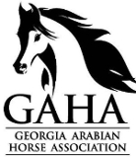
Office Use Only
Year
Date Received
GAHA Member:
AHA Member:
BOD Approval Date:
2020 Frequent Rider Program
Georgia Arabian Horse Association
In conjunction with Arabian Horse Association’s FRP
www.Georgia-Arabian.com

The Frequent Rider Program (FRP) awards riders for every hour that they spend riding or driving an Arabian or Half-Arabian/Anglo-Arabian horse in non-competitive activities. The best part of the FRP is that the type of riding doesn't matter as long as it is non-competitive! Whether you use an Arabian or Half-Arabian/Anglo-Arabian horse to trail ride, do ranch work, participate in parades, take riding lessons, train under saddle or just ride or drive for pleasure, you can now be recognized and awarded for what you love most.

To learn more about the Arabian Horse Association’s FRP and to sign up visit:
https://www.arabianhorses.org/competition/open-programs/incentive-programs/

You MUST be signed up with Arabian Horse Association’s Frequent Rider Program and a member of GAHA to participate for FREE in GAHA’s Frequent Rider Program Awards Program. Riders who would like to compete in the FRP must fill out the AHA Incentive Program Sign-Up Form and pay a one time $25 processing fee to join on AHA.

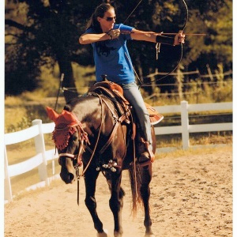
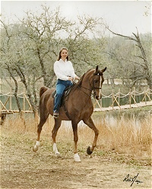
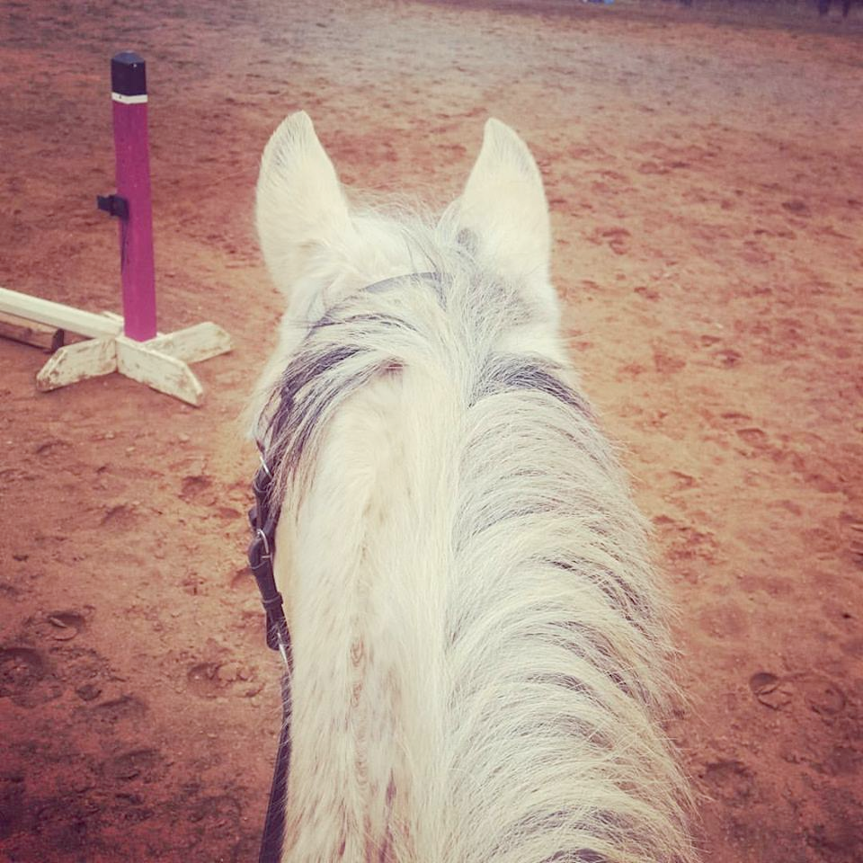
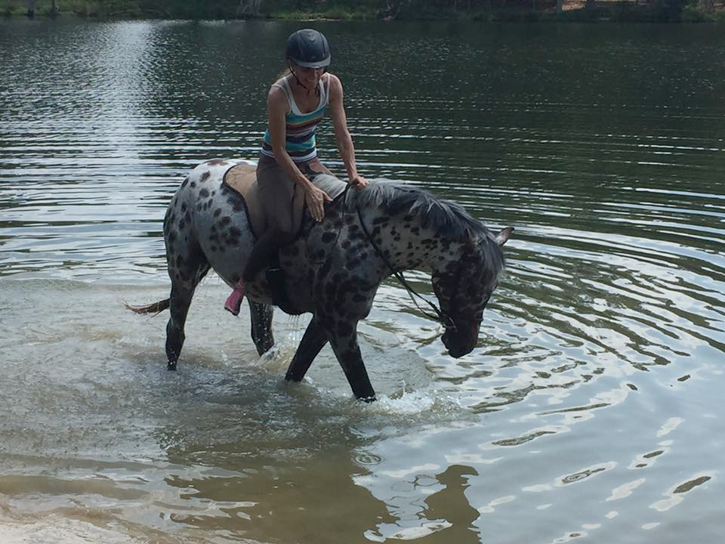
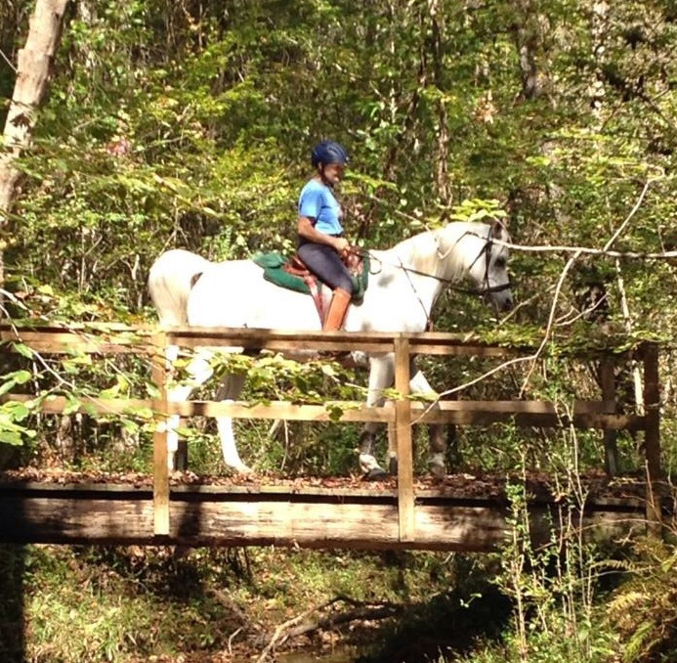
Program participants are defined as an individual rider, not a specific horse and rider combination. This means that as a rider, you may ride any number of horses, regardless of whether you own them or not, as long as they are all Arabians or Half-Arabian/Anglo-Arabians registered with the Arabian Horse Association.

Which activities are recognized? The FRP will recognize any activity with a registered Arabian or Half-Arabian/Anglo-Arabian horse, as long as the participant is riding/driving the horse. Some examples are:

- Trail Riding
- Parades
- Riding Lessons
- Training Under Saddle
- Ranch Work
- Demonstrations
- Pleasure Riding
- Pleasure Driving

Hours that do NOT count are any non-riding activities that might include: Groundwork, Feeding, Cleaning Stalls, Tacking Up, Trailering, Veterinary Care.

Only non-competitive riding or driving hours, logged through the AHA website from December 2nd- December 1st of one calendar year, count towards the GAHA End of Year Frequent Rider Awards.

Hours MUST BE sent to GAHA FRP Chairperson NO LATER THAN December 1st of the award year to be eligible for GAHA Award Banquet to be held January of the next year. You can print a copy of your hours off the Arabian Horse Association’s website to submit to our chairperson. BE SURE TO RECORD YOUR HOURS ON THE ARABIAN HORSE ASSOCIATION WEBSITE.
Any questions please email GAHAFRP@gmail.com

2020 GAHA Frequent Rider Program End of the Year Awards Sign Up Form
In conjunction with Arabian Horse Association’s FRP

GAHA/AHA MEMBER INFORMATION

AHA #: _______________________________________

AHA Horse Registered Name: AHA Horse Registered #:
(if needed) #2 AHA Horse Registered Name: #2 AHA Horse Registered #:

Member Name: Address: _____________ if a minor age: __
Phone:
Mobile:
E-mail:

Signature of Applicant: Date:_______________________

Please email form to GAHAFRP@gmail.com

REMEMBER: YOU MUST be signed up with Arabian Horse Association’s Frequent Rider Program and be a current GAHA member to participate for FREE in GAHA’s Frequent Rider Program Awards Program. Riders who would like to compete in the FRP must fill out the AHA Incentive Program Sign-Up Form and pay a one time $25 processing fee to join on AHA.
GAHA Member FRP Participants with the highest hours at the end of the year will be eligible for awards.

All GAHA & AHA members in good standing are eligible to participate in the GAHA Frequent Rider Program with nomination submission. Hours are earned January 1st through December 1st. Nominee must be a GAHA & AHA member in good standing at the time points are earned. Questions? Contact our GAHA Frequent Rider Program Chair at gahafrp@gmail.com

