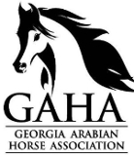
2020 Kids 10 years and younger Frequent Rider Program
Presented by the Georgia Arabian Horse Association

www.Georgia-Arabian.com

The GAHA Kids Frequent Rider Program (FRP) is offered for Kids 10 years of age and younger. This program has reduced hours so that the kids can achieve goals faster while learning to ride. It provides encouragement for them to work hard and have fun riding. Who doesn’t want to collect prizes for having fun??

The Child MUST be a GAHA member to participate in GAHA’s Kids Frequent Rider Program Awards Program. Riders who would like to compete in the FRP must fill out the Sign-Up Form and pay a $25.00 Fee to get started. Your Child can be signed up with the Arabian Horse Association FRP (you would pay AHA the $25) or through the Open GAHA FRP program (you would pay GAHA your $25 fee). The difference between the two programs is that the GAHA program only allows you to ride unregistered Arabians and Arabian crosses and you only need to have a GAHA membership. With AHA you can only ride registered horses and you need to be a member of both AHA and GAHA. Both programs are great! All you need to do is fill out the signup form and get your paperwork turned in. Hours do not count until you have signed up for the program. Hours with our program start at 10 hours and go up. The prize levels are 10hrs, 25hrs, 50hrs, 75hrs, 100hrs, 150hrs, and 200hrs. From there they are added to the regular prize hours. We know that many kids participate in weekly lessons, so we wanted to create a program for them to excel and be included.

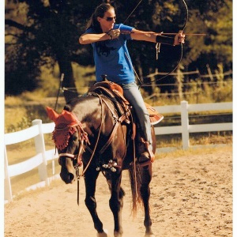
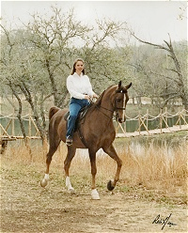
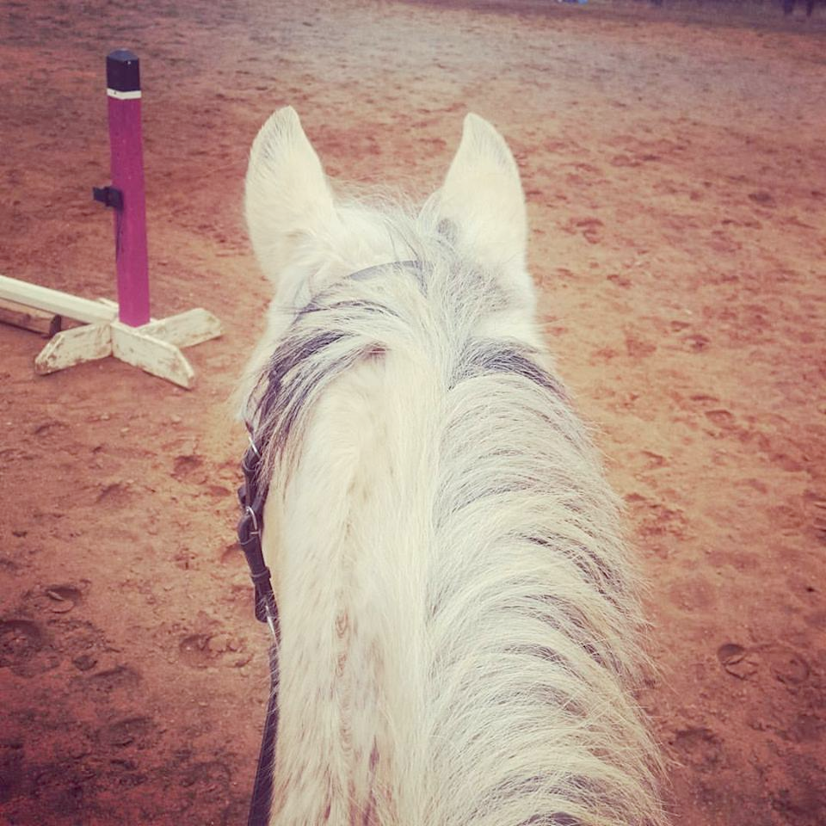
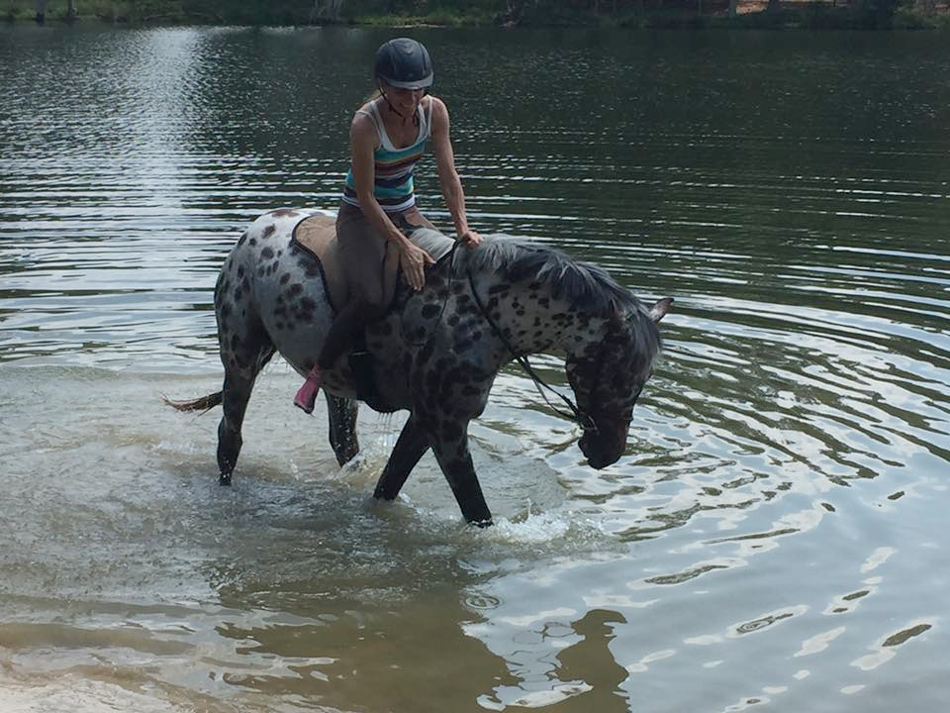
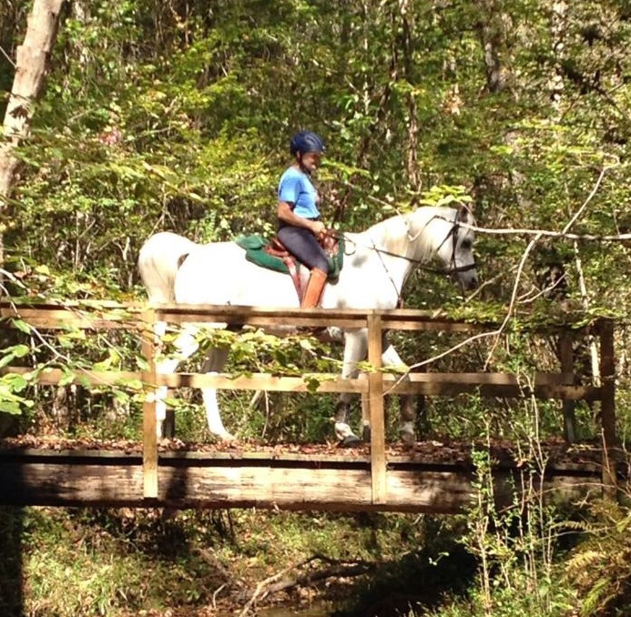
Program participants are defined as an individual rider, not a specific horse and rider combination. This means that as a rider, you may ride any number of horses, regardless of whether you own them or not. You simply need to keep a log of your riding/driving hours. You can mail or email the log in sheets as you finish them. Please make sure that you fill them out completely and include the type of riding and the location.

Which activities are recognized? The FRP will recognize any activity with your horse, as long as the participant is riding/driving the horse. Some examples are:

- Trail Riding
- Parades
- Riding Lessons

. Ranch Work
- Demonstrations
- Pleasure Riding
- Pleasure Driving

Hours that do NOT count are any non-riding activities that might include: Groundwork, Feeding, Cleaning Stalls, Tacking Up, Trailering, Veterinary Care.

Only non-competitive riding or driving hours, logged from December 2nd- December 1st of one calendar year, count towards the GAHA End of Year Frequent Rider Awards.

Hours MUST BE sent to GAHA FRP Chairperson NO LATER THAN December 1st of the award year to be eligible

for GAHA Award Banquet to be held January of the next year. You can email your log in sheets or mail them to:
Angel Johns
100 Cottonwood Trail
Canton, Ga. 30115

Any questions or for more information please email GAHAFRP@gmail.com

Office Use Only
Year
Date Received
GAHA Member:
OD Approval Date:

2020 GAHA Kids 10 years and under Frequent Rider Program End of the Year Awards Sign Up Form

GAHA MEMBER INFORMATION

Horse Name: Horse #2 name: ________________________________
(if needed) Horse #3 Name:

Member Name: _____________________________

Address:

City State: Zip:
Phone:
Mobile:
E-mail:

Signature of Applicant: ___________________________Date: _________________

Please email form to GAHAFRP@gmail.com

REMEMBER: YOU MUST be a current GAHA member to participate in GAHA’s Kids Frequent Rider Program Awards Program. Riders who would like to compete in the FRP must fill out the Program Sign-Up Form and pay a $25 processing fee to join.
GAHA Member FRP Participants with the highest hours at the end of the year will be eligible for awards.

